**Name: محمد احمد عبد الفتاح احمد**

**Course code: ECE001**

**Date: 2019_2020**

**BN: 648**

**Title: - Programming Languages**

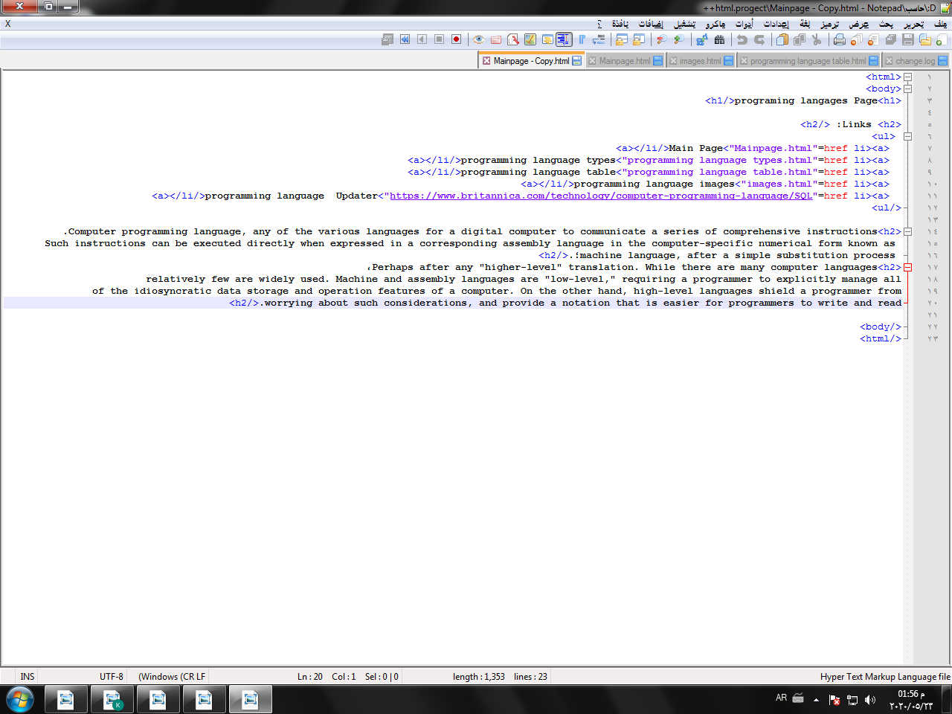Sectionscreenshots: 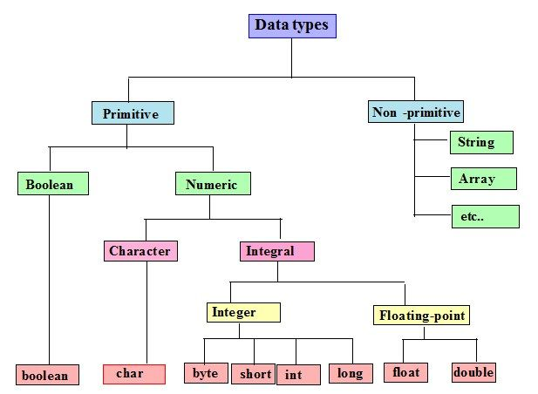

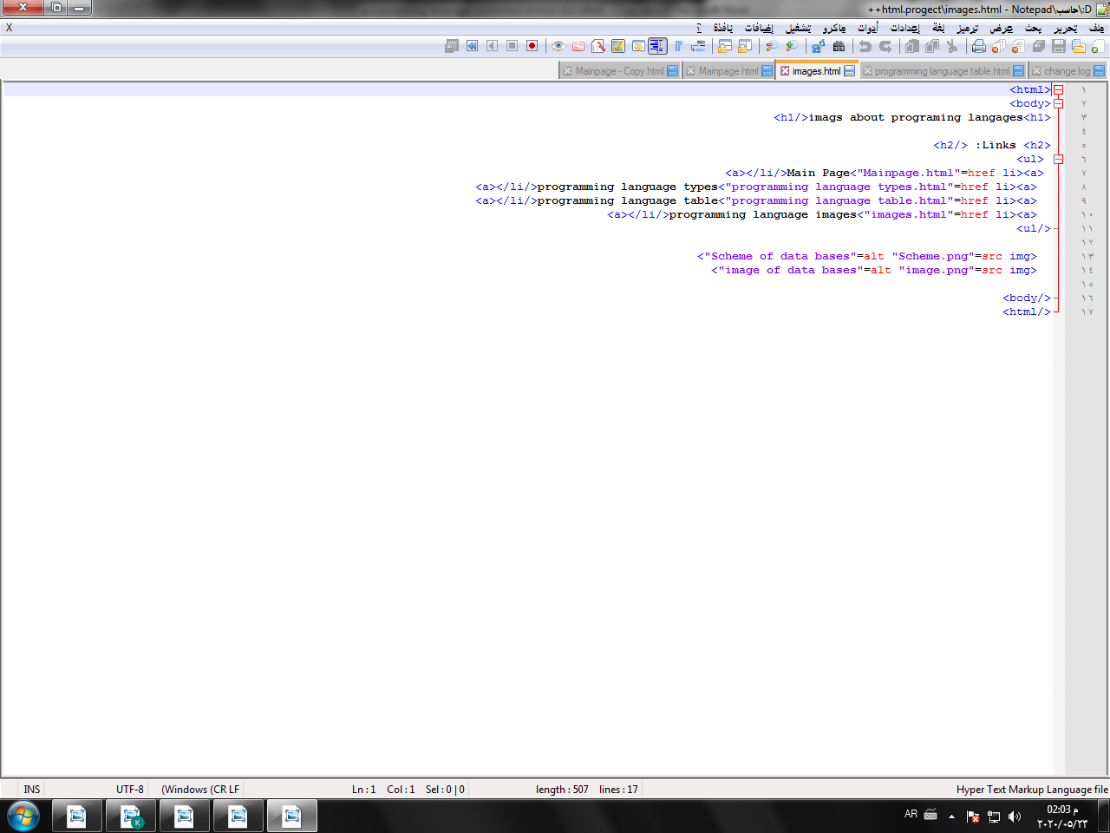

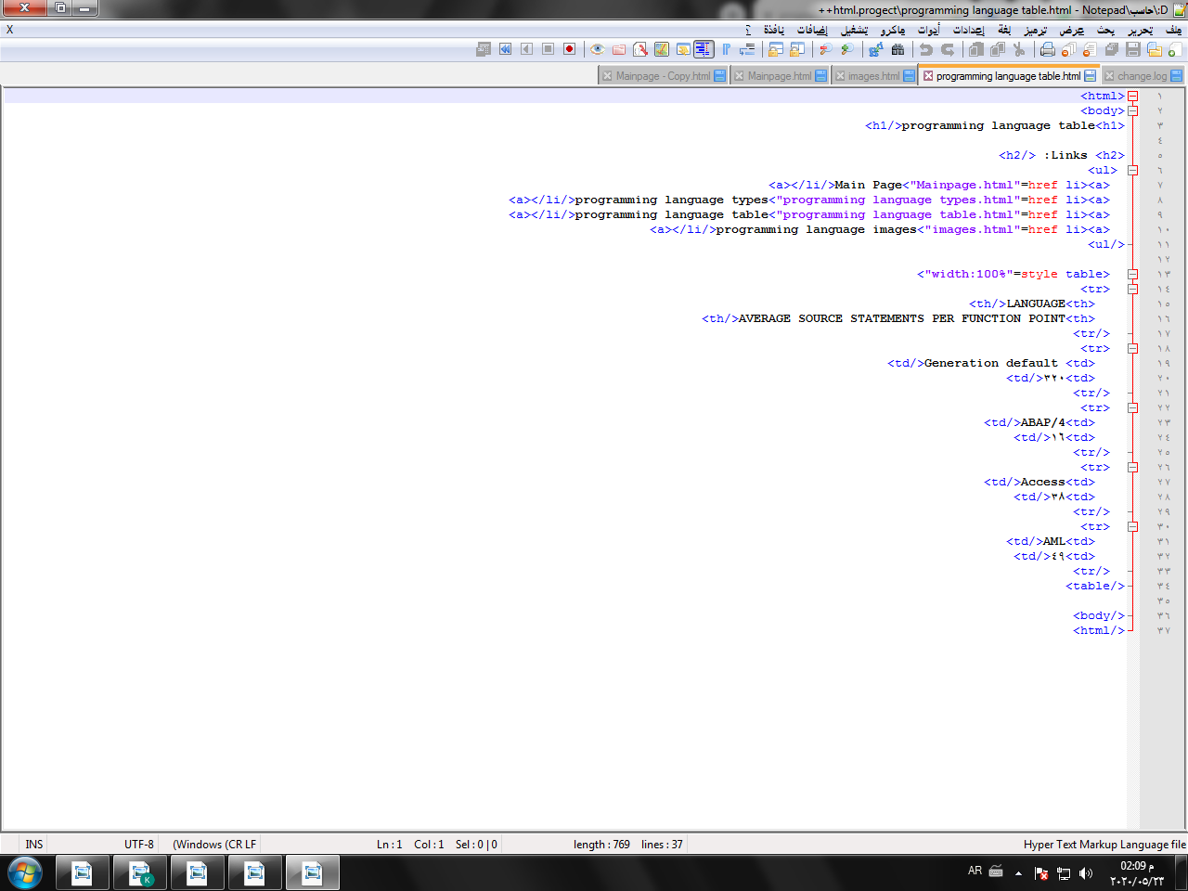

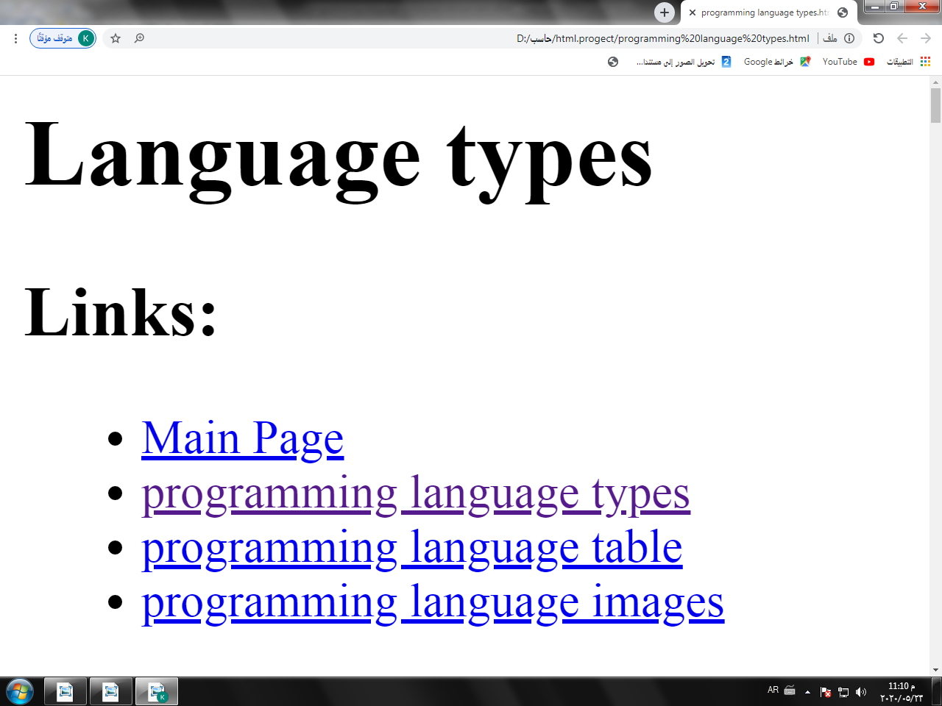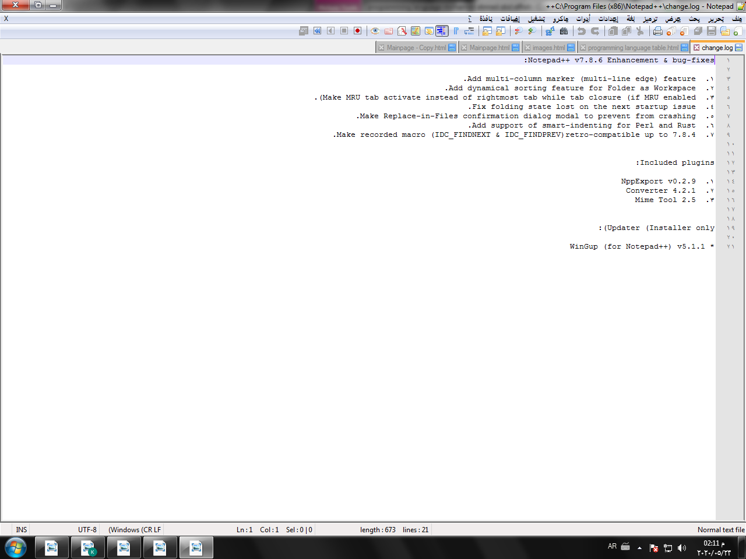

**Application brief:**

**The Programming Languages are:**

We use programming language to communicate with a machine and to send it a collection with things to complete.

The programming languages can be divided into two major groups: programming at high level Languages and programming languages of poor quality.

The programming languages at the higher level are easier to code in. The key words and syntax are narrower

That makes it easier to write to how we think and speak. Though they are easy to us, they are

Computers are very complex; since they're far from the languages computers understand Called Language Machine. When a program is written in a programming language of high quality, it must be

Computer-understood, it needs to be compiled into the machine language. When we utter the word

We usually mean programming languages of high quality, such as Java, Ruby or Python. Python. At the other hand, the low-level programming languages are more difficult to code in. They are much closer to actual machine code than programming languages at the highest level, and require a lot deeper understanding of how computers work and the language of machines to make effective use of these.

Any of using low-level programming languages Benefits are that they can run the software even more easily. The code that has been written needs to be translated much less because the machines grasp it much more easily as the development process is much faster for low-level languages than every high-level programming language has to go through. Low-level programming languages also run at incredibly limited footprint for memory..

# Programming Languages types are:

Language of C + +

The language C++ has an object oriented framework used in broad projects. Programmers may collaborate on each part of the program with one program in separate sections, or even with one person job. The object oriented framework also enables frequent reuse of code. This language is an efficient language. But, many programmers disagree with that

PHP Sprache

The PHP language is used to design web pages, and is sometimes used as scripting language as well. This language is designed to create a fast website, and therefore includes features that make it easy to generate HTTP headers and connect to databases. It includes a collection of components as a scripting language which helps the programmer to easily get up to speed. This does have more sophisticated object oriented functionality, however.

Java language

The Java language is a language of multiple platforms which is especially useful in networking. Of course, with Java applets mostly this language is used on the web. However, in structure and syntax, this language is used to build cross-platform applications, since it is close to C++. Java language is very simple to learn for C++ programmers, and provides some advantages of object-oriented programming. Including reusability and the writing of effective code in Java can be difficult. But the speed of the Java language has increased nowadays, and version 1.5 offers some good features for easy program making.

Pascal Language

Pascal language is mainly a language of teaching and this language is used by few industries to compose the programmes. In C language this language tends to use keywords rather than symbols and braces. So beginners understand this language more quickly than a programming language such as C, C++. Borland is a software compiler company that uses Delphi programming language for strength of industry. Delphi is an object-oriented Pascal language, and currently only use it by Borland compilers.

Language: C

The C language is a simple programming language and is a very common language, particularly used in game programming, since C language requires additional C++ packaging, every programmer uses this language because it makes programs faster. However, the importance of this language gives C++ the reusability to get the small performance improvement with C language.